# Scholarship Programs and Financial Aid in Michigan for International Students

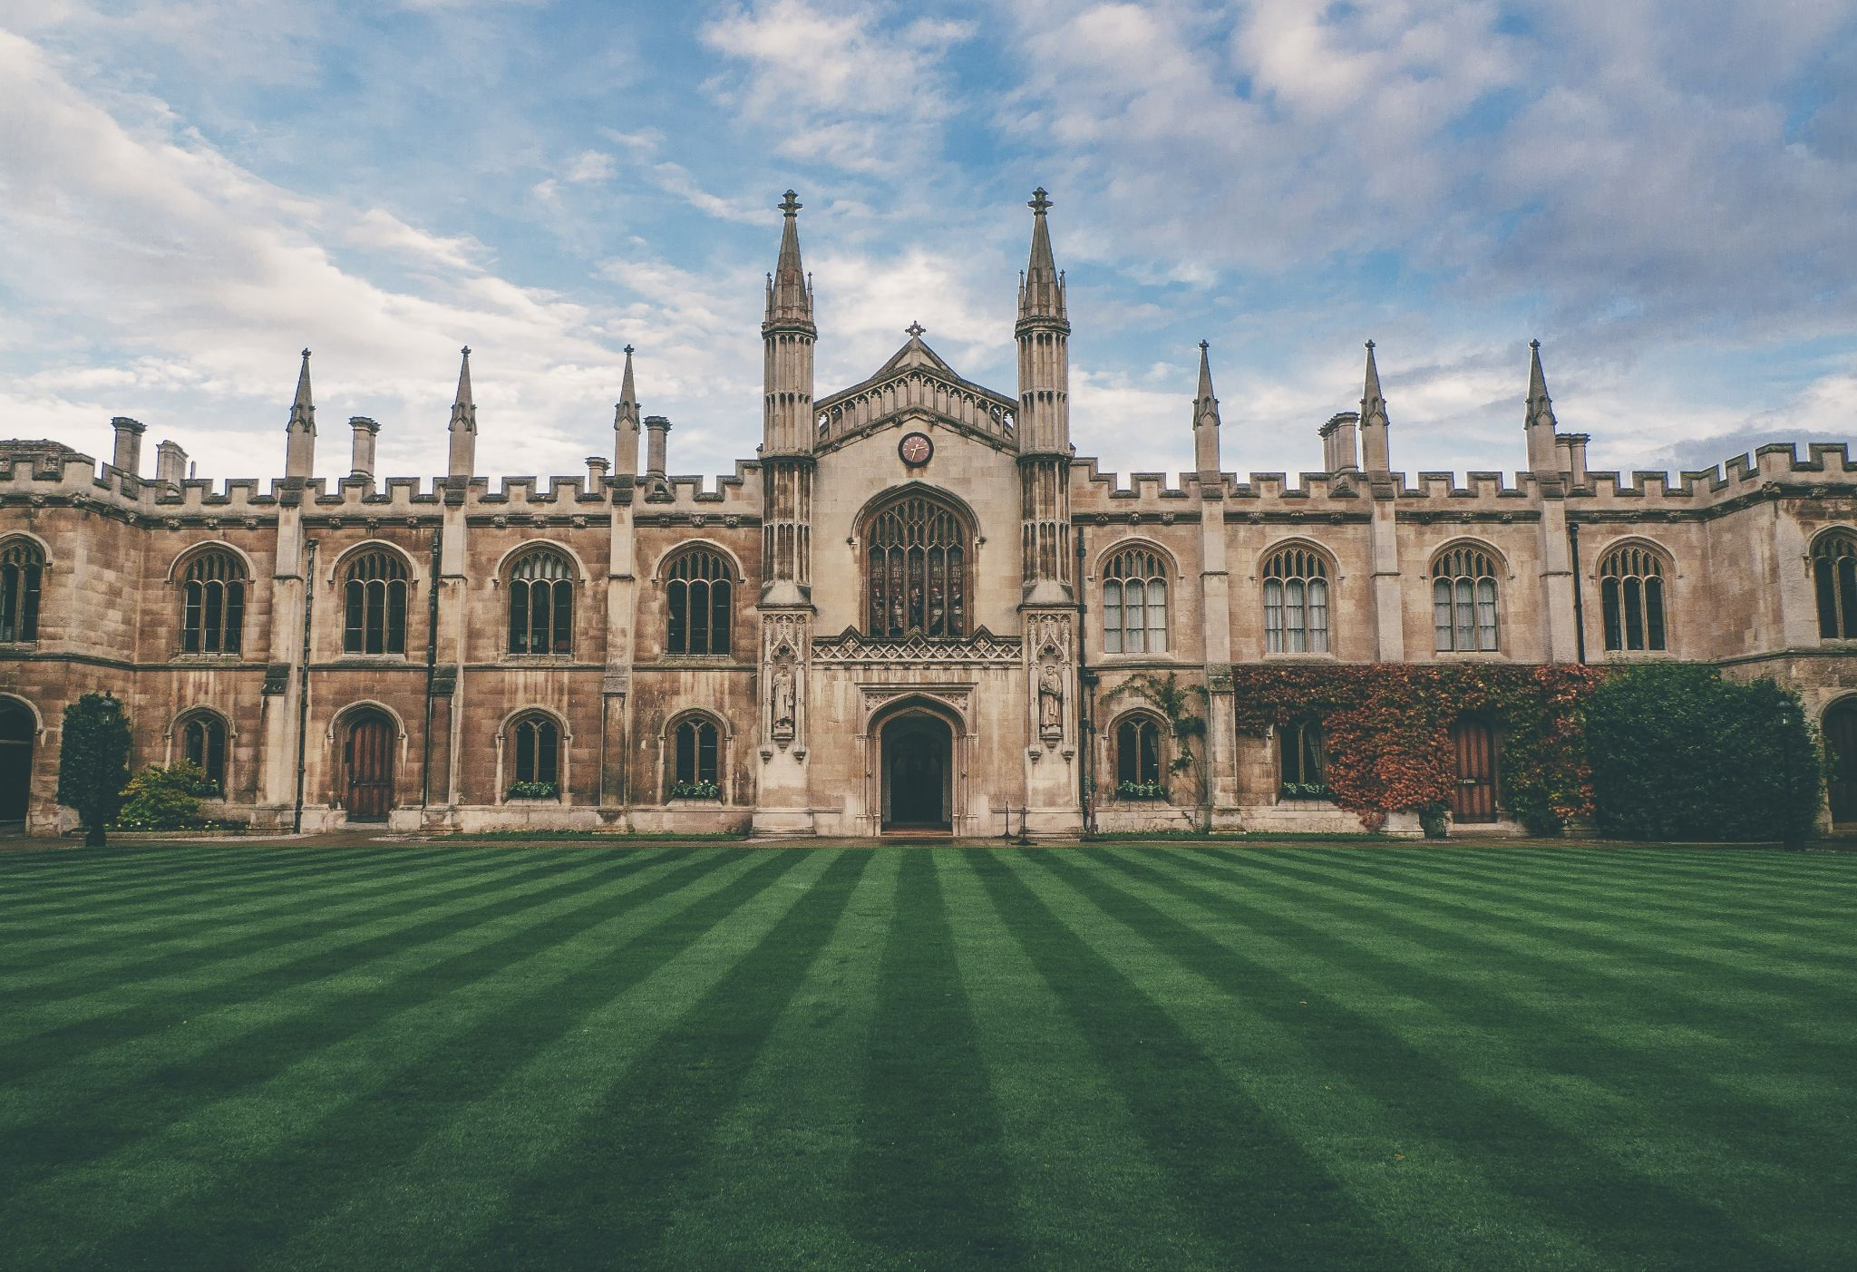

<https://images.unsplash.com/20/cambridge.JPG>

That is prestigious to graduate from the University of Michigan. Such a degree is on the wish list for many people. The good news is that international students can receive more scholarships now than it has ever been before. The sources for the aid are threefold: the governmental, specific institutions, and private organizations. We will talk about them revealing the top 5 scholarship programs in Michigan. Likewise, on how an international student may obtain financial aid. Here we go!

## About Michigan University

To start with, let us describe Michigan University. It consists of 19 schools and colleges under the Ann Arbor Colleges name. That is the website where one should clarify the available opportunities for financial aid. More than one hundred and twenty countries have already their international students at the University of Michigan. Moreover, Michigan has an international community being the 9th in the world for the number of international students. For example, almost thirty thousand foreigners studied here in 2014.

We should note that scholarships that cover all requirements and needs of international students are exclusively rare. Only genius gains one of them. The explanation goes below.

## About Full-Coverage Scholarships

Numerous programs help and support USA citizens. They are for the students with excellent marks or families having difficulties but have done everything to educate their children. However, we are here to research federal statutes and university rules on behalf of international students.

The answer is that the university requires students to have enough money to cover living while studying. That relates to students with F, J, and G classes visas. Those markings give the right to learn at USA universities, colleges, and exchange programs. Although one may get approval to study in the USA, one has no full financial support from the government.

Still, there is an option to get some partial aid!

That partial financial help may cover something, such as tickets, apartments, or be a pleasant one-time payment. In any case, that makes your life easier. Let's read more regarding that.

## Aids for non-residents of the USA

The standard helping payment for foreigners deviates from 25% to 50% of the chosen program cost. The scholarships can go to both Bachelor's, Master's degrees, and Ph.D.

The competition is lower for the latter two. So, what program should we as non-residents of the USA choose now, and what do we need to do to become successful applicants?



<https://images.unsplash.com/photo-1495995424756-6a5a3f9e7543>

## # Assistantship

Get an assistantship position at a university to save money on education in the USA. Michigan University supports that type too.

That is, in fact, an on-campus job offered to master and Ph.D. students. Getting the desirable position, they work as an assistant at the university for up to 20 hours weekly. As a gratitude to the work a student does, the university may not require checks from him, up to 100% free education. In addition, it may cover even personal expenses. Sounds pleasing, right?

Two types of assistantships are:

* When a student participates in research work;
* Engaging in teaching others.

Conditions deviate from university to university. In general, one has to be an undergraduate Bachelor and practice English at C1. Then, to pass GPA and GREs. Do not forget to prepare a motivation letter. Make it convincing and tell about your goals. When you write, trust the tips of your tutor or use any [research paper writing service reviews](https://topwritingreviews.com/services). That is hard to write about yourself when your life depends on that paper. You are not the first person who encounters that. To simplify your task, we collected reliable [websites ratings](https://ratedbystudents.com/services). You can compare some aspects and choose what service will be your helping hand.

## # Fulbright Program

In addition to university scholarships, there are government initiatives. The Fulbright Program is the most famous one. Young scientists, teachers, undergraduates, and masters receive that grand from 155 countries. It is well-known in the world.

The program takes care of all expenses. One can pay for the three years of magistracy education with the grand. One even covers medical insurance, so necessary in the USA. That is great! Moreover, successful students get free tests, flights, and educational materials. The student has the resources to devote all his time to studying. It is so because there is no need to think of arranging accommodation and meals.

The Fulbright program is valid for a specific list of specialties. You can find it on the official [website](https://ii.umich.edu/ii/fulbright-program.html). The purpose goal of the program is to establish cultural ties between the United States and the student's homeland. Therefore, after graduating from the magistracy, he must return to his homeland to apply the acquired knowledge in practice. It will be possible to apply for a migration visa no earlier than two years later.

## # American Association of University Women

AAUW runs an International Fellowship program for women from all over the world. The scholarship cuts education costs and allows women to do research at an American university. That way, they can become leaders in their home countries in the future. The program is open to all specialties and is available at the University of Michigan. You need to apply for a scholarship after applying to an American university.

## # Civil Society Scholar Awards

It is Open Society Foundations that runs this program. Its purpose is to stimulate socially significant research. It is available to doctoral or Ph.D. students from post-Soviet countries: Azerbaijan, Georgia, Moldova, Tajikistan, Turkmenistan, Uzbekistan. Students of any social and human rights fields can apply. The scholarship lasts ten months. The funding amount is USD 15 000.

## # Northern Michigan University Scholarship

Northern Michigan University offers a scholarship to the best students entering one of the undergraduate programs. Talented international students enrolled in full-time studies receive the scholarship automatically. With it, they gain the title of an associate or bachelor's degree from Northern Michigan University. The scholarship participants will be involved in the cultural and social activities of the university.

Students will receive $2200 annually based on excellent academic performance. The scholarship is available for eight semesters to undergraduate students and up to 6 semesters to students who transfer to Northern Michigan University from another university. If one succeeds, one can prolong the program and keep on learning.

## How can one apply?

That is an achievable task to obtain financial aid for a foreigner at Michigan University. It is still challenging, though. It is so because there is no united system to receive applications from international students in the USA. There is no distribution system. Thus, to enter Michigan University, one should apply to every college separately. It costs a small fee and time to learn all options.

### Try FAFSA

The best way to determine which scholarship you can apply for is to complete the FAFSA application [here](https://studentaid.gov/). That application of the Department of Education determines whether a student has a right to get financial aid for college. An applier should comply with admission requirements and language tests, show outstanding results in the chosen field, and go through bureaucracy to become a successful candidate. The mentioned aid includes federal grant programs (such as the Pell Grant), federal work-study, and federal student loans.

Note! The university offers a short-term loan at a low-interest rate for full-time international students. Use it as a last resort in emergencies. It requires applicants indicate the sources for loan repayment.

### Contact the desired college

Another way is to ask about existing opportunities at the college or school directly. If you have outstanding sports achievements, apply through the University of Michigan Athletic Department. That may provide you with potential scholarships in this field.

For students to get a bachelor's degree, create their unique curriculums by choosing out of 263 disciplines. More great teachers and professors gained a national and international reputation. They are your helping hand in excellence in teaching and research. Michigan university provides exceptional opportunities for students to learn under their guidance in any academic discipline.

Every dream may come true if you are persistent and work hard. Look for opportunities, prepare documents and letters. By doing so, you will implement the idea to get the recognizable degree of the University of Michigan into life!